## Line Following

The following information composes the justifications that were made to make a decision on the line following equipment for Roadie.

### Items Under Consideration

|  |  |  |  |
| --- | --- | --- | --- |
| **Item ID** | **Name** | **Vendor** | **Description** |
| ROB-09454 | QRE1113 (Digital) | SparkFun | This product utilizes a capacitor in order to rapidly determine exposure of light by using the time of discharge. [1] |
| GL5516 | Optoresister GL5516 | Amazon | An inexpensive method of detecting light. |

Table X: Line following equipment under consideration for Roadie

### Decision Matrix

|  |  |  |  |  |  |
| --- | --- | --- | --- | --- | --- |
| Factor | Cost | Ease | Availability | Community | Total |
| Weight | 0.1 | 0.4 | 0.2 | 0.3 | 1 |
| Line Sensor Breakout - QRE1113 (Digital) | 1 | 5 | 5 | 4 | 4.3 |
| Photoresistor Optoresistor 5mm GL5516 5516 | 5 | 4 | 5 | 2 | 3.7 |

Table X: Decision matrix for line following equipment

|  |  |  |  |  |
| --- | --- | --- | --- | --- |
| Factor | Cost per unit | Ease | Availability | Community |
| ROB-09454 | $2.95 | Compatible with Udoo | In stock | Online help easily found. Great support for Arduino IDE. |
| GL5516 | $0.249 | Compatible with Udoo | In stock | Various online tutorials can be found. |

Table X: Quantitative and qualitative values of the line following sensors under consideration that led to the decision matrix.

### Justifications

#### Cost

Both options were very cheap compared to the rest of the system’s components, with the photoresistors being $4.98 per 20, and the QRE1113 being $2.95 each. Within the decision matrix, the scale was based so that 1 was the most expensive on the scale and 5 was the least expensive. Even so, the price of both factors is fairly low.

#### Ease

The ease category related to the ease of integration with the microprocessor. There are many tutorials available for the integration of the QRE1113 with Arduino IDE, and some are available for generic photoresistors as well which include the GL5516.

#### Community

The community is weighted fairly heavily since it is meant to regard how easy it is to find information and tutorials about the item. A large amount of information was found about the QRE1113 model specifically. Some information was found about generic photoresistors, but not nearly as much as the QRE1113.

#### Availability

The availability relates to how easy the item can be bought and replaced if the need arises. Both items are inexpensive and easy to find on the internet. There are no foreseeable issues in finding sources of the items.

### Overview

Both items are relatively inexpensive compared to other system components. The main concern in selecting an item for line following was ease of implementation and the community. With a large amount of information available for the QRE1113, it seems to be the best option to allow the team to efficiently implement line following for the system.

## Risk Analysis

This section will include information regarding risks related to the line following equipment and solutions to mitigate those risks. The probability of each occurrence, denoted as **Prob.**, will give the likelihood on the scale of 1 to 5. 1 will be the lowest likelihood while 5 will be the highest. The severity of an occurrence, denoted as **Sev.,** will give the amount of impact that an event will have, similarly as before with 1 being lowest impact and 5 being the highest.

|  |  |  |  |
| --- | --- | --- | --- |
| **Risk** | **Prob** | **Sev** | **Mitigation** |
| Sensing distance changes | 1 | 4 | Ensure that proper measures are taken during construction of each prototype to keep the sensor in the same spot. As long as the sensor is secured tightly and properly to the system, there should be no surprises on competition day. The sensor's optimal distance is 3mm. [1] |
| Improper reading | 2 | 4 | Have redundancy of sensors. There will be five sensors attached to the system so that readings on each sensor can be compared to obtain the most accurate readings. |
| Damaged sensor | 1 | 2 | In the event that a sensor is damaged, one can be easily attached in its place. Having one or two backup sensors in case one fails will mitigate this risk. |

**Table x.** The major risks and mitigation for the system’s line following equipment.

## Requirements Traceability

|  |  |  |
| --- | --- | --- |
| ID | Requirement Text | Fulfilment |
| 3.2.1 | The system shall track its movement along the Scotch Blue Painter’s tape. | The QRE1113 will allow Roadie to sense the tape in order to allow the system to coordinate its movement along the tape. |
| 3.2.2 | The system shall be able to identify the challenge areas in order to stop movement. | The QRE1113 will allow Roadie to sense challenge areas in order to allow the system to stop its movement. |
| 3.3.1 | The system shall correctly identify the challenge zone upon arrival. | The QRE1113 will be able to sense when the tape splits in order to identify challenge areas. |
| 4.3.2 | The system shall be completely autonomous after being powered on. | The QRE1113 will allow Roadie navigate independent of human intervention. |

# References related to Line Following

[1] Line Sensor Breakout - QRE1113 (Digital) - ROB-09454 - SparkFun Electronics. (n.d.). Retrieved October 5, 2014, from https://www.sparkfun.com/products/9454

[2] Amazon.com: 20 pcs Photo Light Sensitive Resistor Photoresistor Optoresistor 5mm GL5516 5516: Car Electronics. (n.d.). Retrieved October 5, 2014, from http://www.amazon.com/Sensitive-Resistor-Photoresistor-Optoresistor-GL5516/dp/B008FUT7K6/ref=sr_1_1?ie=UTF8&qid=1412273416&sr=8-1&keywords=photoresistor

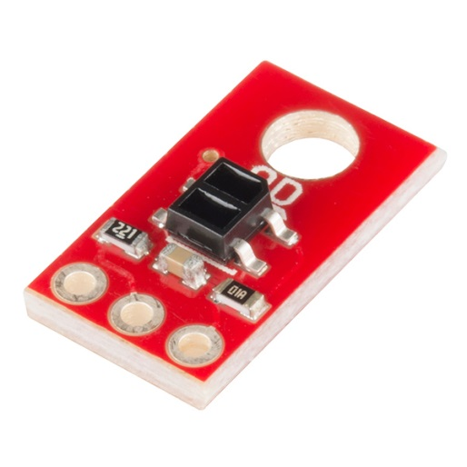  
QRE1113

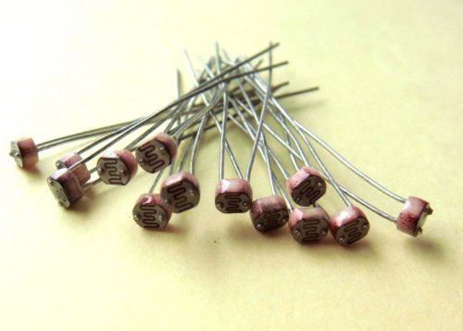

GL5516